**OLABISI ONABANJO UNIVERSITY**

College of Engineering & Environmental Studies

Faculty of Engineering

Ibogun Campus.

**MECHANICAL ENGINEERING DEPARTMENT**



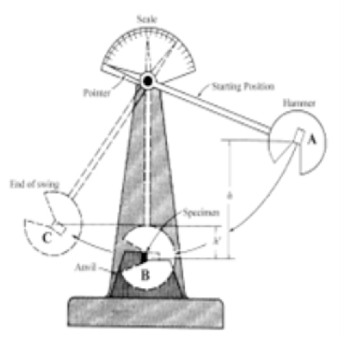**STRENGTH OF**

**MATERIALS**

**LABORATORY MANUAL**

**300 LEVEL**

**NAMES…………………………………………………………………………………........ MATRIC. NO. :……………………………… LEVEL: ……………………………….. DEPT.: ……………………………………….. GROUP NO: ………………………… COURSE:…………………………………….. CODE: ………………………………... DATE:………………… SESSION:………… SIGNATURE: ………………….........**

***Published, 2017, Reprinted, 2019, by***

**MECHANICAL ENGINEERING DEPARTMENT OLABISI ONABANJO UNIVERSITY**

College of Engineering & Environmental Studies,

Faculty of Engineering

Ibogun Campus.

*All rights reserved. No part of this book may be reprinted, reproduced, republished or repackaged or utilized in any form or by any means – electronic, mechanical, now known or to be inverted in the future, including photocopying and recording or in any information storage or retrieval system, without prior permission in written form to the publisher.*

**PREFACE**

This manual is a compilation of information on the practical aspect of the programme available for the undergraduate programme in the Department of Mechanical Engineering. The Department presently offers a Bachelor of Science (B.Sc.) degree in Mechanical Engineering. The Department is one of the five engineering programmes in the College of Engineering and Environmental Studies and is equipped with seasoned and well-trained academic staff and qualified academic technologists personnel who are prepared to help the students to develop themselves through research, engineering practice and creativity. The Department places great emphasis on the practical application of engineering and scientific principles to produce industry-ready engineers, who are immediately employable and capable of adapting to an ever-changing future. Mechanical Engineers are responsible for the application of engineering principles to design, production, processing to provide solutions to complex real-world problems by using different engineering applications and other cutting-edge technologies.

In order for the Department to meet her targeted goal and objectives, the Department sets high standards of moral and academics for all her students, and they are guided and monitored to meet up with those standards. This manual contains information on the practical classes of the different aspects of Mechanical Engineering for the purpose of guiding students for smooth academic pursuit in the Department. Graduates from the Department are being trained to develop their personal initiatives and to possess intellectual independence as well as to be creators of employment.

***Head, Department of Mechanical Engineering,***

**Olabisi Onabanjo University, Ago-Iwoye.**

**INTRODUCTION**

**1. General**

The need for laboratory work in Mechanical Engineering is very important. Laboratory's course work enables students to do experiments on the fundamental laws and principles encountered in the theoretical work; to study and use a wide variety of measuring instruments and equipment, to learn and to handle them with skill and to appreciate their limitations.

**2. Conducting the Experiments**

The experiment should be planned in advance by consulting necessary reference books in order to understand the principles behind the experiment. Before starting the experiment, the following steps should be taken:- i. Produce the Sketch for the experiment, ii. Produce the working diagram of the experiment, iii. Write down, in the form of a table, all the measurements you propose to make, and the calculation or formula to be used to obtain the results.

**3. Records**

A faithful record of all observations taken should be made in the space provided in the tables contained in the laboratory manual and should be duly signed by the supervisor. To obtain accurate results, repeat the experiment using different methods where possible. The account of the experiment should be written in a practical notebook, which has graph paper on alternate pages. If the notebook is not ruled for graphical work, a sheet of graph paper can be interleaved when necessary between the double pages of the record. The report should be in a suitable format as follows:- i. Title, ii. Objectives, iii. Equipment/Apparatus/Materials,

iv. Theory/Diagram, v. Method/Procedures, vi. Measurements/Results, vii. Calculations viii. Graphs, ix. Results or Conclusion, x. References

**4. Attendance**

All students who registered for the laboratory courses must attend classes when required. There is a system of taking attendance register and this is considered when grading your laboratory work/report.

**5.0 Reference Tables**

**5.1 Multiple and Sub-multiples units and their abbreviations**

T = Tera = 1012, f = femto = 10-15

G = Giga = 109 , p = pico = 10-12

M = Mega = 106 , n = nano = 10-9

K = Kilo = 103 , u = Micro = 10-6

M = Milli = 10-3

1 MPa (MegaPascal) = 1 × 106 N/m2 = 1 N/mm2

1 GPa (GigaPascal) = 1 × 109 N/m2 = 1 kN/mm2

**5.2 Common Abbreviations**:

mA = milliAmeter, d = diameter, t = thickness, s = second, σ = stress, ε = strain

*l* = Original length of the body, Δ*l* = Change in length of the body, and

*E* = Young's modulus or modulus of elasticity*,* τ = Shear stress,

ϕ = Shear strain, *C* = Shear modulus (Modulus of rigidity).

**6. Graphs**

Whenever possible, the result of an experiment should be presented in graphical form. In plotting the results, the dependent variable should be plotted as ordinates on the y- axis, and the independent variable as abscissas on the x – axis. The scale used should a convenient one for arithmetical work, and should be sufficiently extensive for the graph to occupy a wide sweep of the space available. On the other hand, too large a scale will tend to accentuate the errors of observation and obscure the relationship between the two quantities.

**7.0 General Laboratory Safety**

Safety is one of the major elements of good laboratory management, but it is perhaps the most neglected. It should be understood that any use of electricity inherently involves some degree of safety hazard. Whilst every effort is made by responsible manufacturers to reduce the hazard, it is still rest with the users to play his part in ensuring his own safety.

The major-causes of laboratory accidents can be categorized into two:

Human cause which includes: i. Carelessness, ii. Ignorance, iii. Wrong attitudes, iv.Negligence.

**Contributory causes:**

I. Physical condition of students,

ii. Unsatisfactory or inappropriate equipment, iii. Diverted attention,

iv. Congested work stand, or inappropriate attire

**The best ways to achieve safety in the use of electrical equipment includes:**

i. Taking no chances, nor short cuts, in safety procedures.

**7.1 Safety**

This manual contains a number of guidelines which can help you perform your research works more safely and maintain better order and safety in our laboratories.

Each student is expected to read this manual thoroughly and act in agreement with the guidelines. This manual should also be kept available for future reference.

There are two golden rules in developing a safe and productive environment:

(1) Whenever you use a lab, it is your responsibility to see that unsafe conditions are corrected immediately; and (2) Always leave a laboratory in better condition than you found it.

If we all take this level of personal responsibility, our facilities can only improve.

We hope to periodically update and revise this manual to make it more useful and more effective. We hope keep you stay safe and productive.

Safety requires a careful and deliberate approach to each test before undertaking any experiment; the student must understand what to do and how to do it.

**7.2 Safety rules:**

The following important safety rules should be observed at all times:

i. Do not clown or gossip in the laboratories, ii. Do not sit on the work bench,

iii. Extraneous items should be removed from the table,

iv. Attention should be paid for clamping the job, tool, tool holders or supporting cutters.

v. Ask for instructions before the use of any item of test equipment for the first, time, even if you think you know how to use it. A little knowledge can be dangerous.

vi. Do not use any ring and wrist watch during practical periods. vii. Do not use any necklace or chain during practical periods. viii. Your hand nails must be dressed and properly maintained. ix. Avoid loose clothes in the laboratory and workshop.

x. Always wear safety goggle where necessary. xi. Do not eat nor drink during practical periods. xii. Ask when you do not know.

**MANDATORY PERSONAL PROTECTIVE WEARS FOR LABORATORY AND WORKSHOP**

i. White long sleeve laboratory coat for laboratory practical. ii. Blue long sleeve overall for workshop practical.

iii. Safety boot / hard sole leather shoe.

**STRENGTH OF MATERIALS**

**Table of Contents**

Introduction -

Experiment 1 - Brinell hardness test. Experiment 2 - Impact test Experiment 3 - Tensile test

Experiment 4 - Reaction at beam supports Experiment 5 - Modulus of elasticity Experiment 6 - Torsion

**EXPERIMENT 1**

**TITLE: BRINELL HARDNESS TEST.**

**AIM**: To determine the hardness of the given specimen using Brinell hardness test.

**EQUIPMENT AND MATERIALS:**

Brinelll hardness testing machine, Ball indenter, Aluminum specimen.

**THEORY:**

Hardness of a material is defined as Resistance to the permanent indentation under static and dynamic load. When a material is required to use under direct static or dynamic loads, only indentation hardness test will be useful to find out resistance to indentation.

In Brinell hardness test, a steel ball of diameter (D) is forced under a load (F) on to a surface of test specimen. Mean diameter (d) of indentation is measured after the removal of the load (F).

NOTE: Thickness of the specimen should not be less than 8 times the depth of indentation to avoid the deformation to be extended to the opposite surface of a specimen. Indentation should not be made nearer to the edge of a specimen to avoid unnecessary concentration of stresses. In such case distance from the edge to the centre of indentation should be greater than 2.5 times diameter of indentation.

Rapid rate of applying load should be avoided. Load applied on the ball may rise a little because of its sudden action. Also rapidly applied load will restrict plastic flow of a material, which produces effect on size of indentation. Surface of the specimen is well polished, free from oxide scale and any foreign material.

**DIAGRAM**

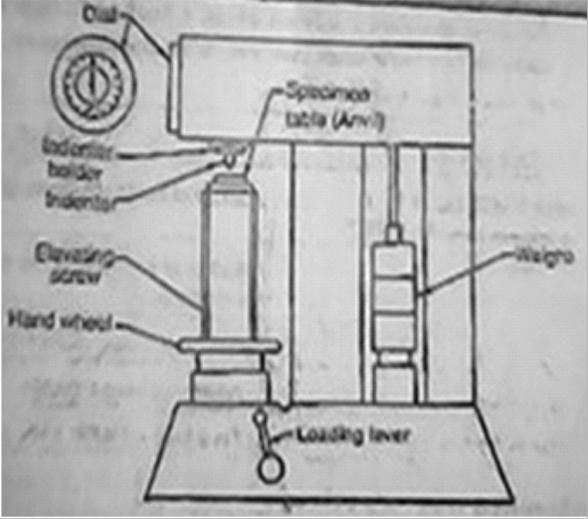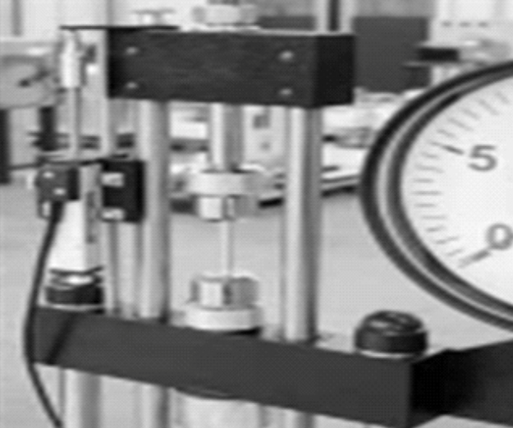

**Figure 1.1: Brinell hardness testing Equipment**

**Procedure**

i. Select the load to be applied for hardness test according to the expected hardness of the material.

ii. Keep the test load equal to 30 times the square of the diameter of the ball (diameter in mm) F=30D2 (Where ball diameter, generally taken as 10 mm).

iii. Apply the load for a minimum of 15 seconds to 30 seconds. [ time for ferrous metals to be tested will be 15 seconds and softer metal will be 30 seconds]

iv. Remove the load and measure the diameter of indentation nearest to

0.02 mm using microscope (projected image), magnifying lens (glass) Guidelines hardness range for standard loads are shown below

**Table 1.1: Specification of materials and load**

|  |  |  |
| --- | --- | --- |
| **Ball diameter** | **Load (kg)** | **Range of Brinell hardness** |
| **10** | **3000** | 96 to 600 |
| **10** | **1500** | **48 to 300** |
| **10** | **500** | **16 to 100** |

Brinell hardness number

2F/(πD[D- (D2-d2)]

where D is the diameter of ball indenter and d is the diameter of indentation.

Hardness numbers normally obtained under 3000 kg and 10 mm diameter ball used for different materials are stated below

Table 4.2: Hardness of materials

|  |  |
| --- | --- |
| MATERIALS | HARDNESS NUMBERS |
| Medium carbon steel | 100 to 500 |
| Structural Steel | 130 to 160 |
| Hard Steel | 800 to 900 |

Note: Brinell test is not recommended for the materials having HB over 630.

It is important to observe and know the ball size and load with the hardness test when standard size of ball and load are not used. Because indentation done by different size of ball and load on different materials are not geometrically similar due to the different in size. When load is applied, ball also undergoes deformation and the material response to the load is not always the same

**RESULTS AND CALCULATION**

i. Take average of five values of indentation of each specimen. Obtain the hardness number from equation.

ii. Compare Brinell and Rockwell hardness tests obtained.

iii. Calculate Brinell hardness number (HB) of the specimen.

**EXPERIMENT 2**

**TITLE: IMPACT TEST**

**AIM**:**Aim:** To determine the Impact toughness (strain energy) through Izod test and Charpy test

**Aim:** To determine the Impact toughness (strain energy) through Izod test and Charpy test

**Theory**

An impact test is a specially prepared notched specimen for fractured by a single blow from a heavy hammer and required energy to measure the resistance to impact. The Impact load is produced by a swinging of an impact weight W (hammer) from a height h. Release of the weight from the height h swings the weight through the arc of a circle, which strikes the specimen to fracture at the notch (Figure 2.1)

Kinetic energy (KE) of the hammer at the time of impact is 0.5mv2, which is equal to the relative

potential energy (PE) of the hammer before its release is mgh, where m is the mass of the hammer and *v* = (2*gh)* is its tangential velocity at impact, g is gravitational acceleration (9.81 m/s2 ) and h is the height through which hammer falls. Impact velocity is 5.13 m/s.

It is interesting to note that height through which hammer drops determines the velocity and height and mass of a hammer combined determine the energy.

Energy used can be measured from the scale given. The difference between potential energies is the fracture energy. In test machine this value indicated by the pointer on the scale. If the scale is calibrated in energy units, marks on the scale should be drawn keeping in view angle of fall (θ) and angle of rise (β). Height h1and h2 equals, h1= R (1- cos θ) and h2= (1- cos β).

With the increase or decrease in values, gap between marks on scale showing energy also increase

or decrease. This can be seen from the attached scale with any impact machine. Energy used in fracturing the specimen can be obtained approximately as

Wh1 - Wh2

The impact toughness/ impact value, would be measured per unit area at the notch.

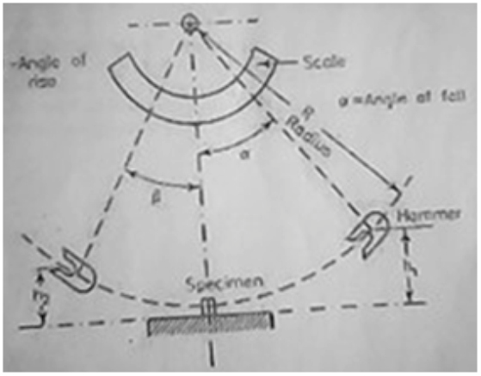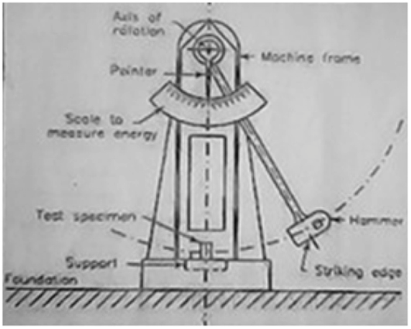

Figure 2.1: Impact testing equipment Figure 2.2: Schematic impact testing

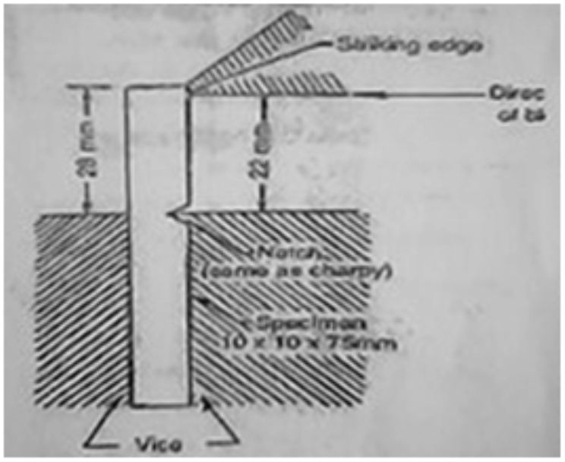

Figure 2.4: Position of specimen for Izod test

**Procedure:**

1. Specimen is clamped to act as vertical cantilever with the notch on tension side. Direction of blow of hammer is shown in figure 2.2

2. Measure the dimensions of a specimen and that of the notch.

3. Raise the hammer of the machine and note down initial reading from the dial pointer, which indicate the energy to be used to fracture the specimen.

4. Place the test specimen at the centre with respect to hammer and check the position of notch.

5. Release the hammer and note the final reading to determine the actual energy required to fracture the Specimen.

6. Repeat the test for other materials specimens.

7. Compute the energy of rupture of each specimen.

**Results and Calculation**

Record the Initial and final reading of the dial in tabular form. Determine the Strain energy of the given specimen

**EXPERIMENT 3**

**TITLE: TENSILE TEST**

**AIM / OBJECTIVE:**

To observe the behaviour of a mild – steel specimen while being tested to destruction and to determine:

a) The value of young's modulus

b) The yield stress for the material. c) The ultimate tensile stress

d) The percentage elongation

e) The percentage reduction of area.

**APPARATUS:**

Machine, Extensometer, divider, steel rule, centre punch, micrometer, vernier caliper, and mild steel.

**THEORY**

Stress = 

Strain =

Young's modulus=

**PROCEDURE**

The diameter of the specimen was measured on several points along its length. The gauge length was selected with centre – punch and hammer. The specimen to be tested was inserted into the jaw of the machine and a small load sufficient to take up the slack was applied. Extensometer was mounted on the specimen (if available). A gradual increased load was applied and readings of load and extensometer at a regular interval was taken. Extensometer was removed when an increase of load leads to a disproportionate extension (indicating yield point). Loading of the specimen continued and readings of load and extension were recorded. Divider was used to measure the extension until the specimen breaks or fractures. steel.

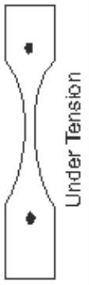Gauge

Length

|  |  |  |  |
| --- | --- | --- | --- |
| Load (kN) | Extension | Stress | Strain |
|  |  |  |  |
|  |  |  |  |

**Exercises: Results obtained from the table** i. Plot the graph of load against extension ii. Plot the graph of stress against strain

iii. Calculate the ultimate tensile stress. iv. Calculate the percentage elongation

v. Calculate the percentage reduction of area vi. Calculate the breaking stress

vii.Suggest precaution for the experiment.

**EXPERIMENT 4**

**TITLE: REACTION AT BEAM SUPPORTS**

**Aim/Objective**: To measure the reaction on the supports of a loaded beam.

**Apparatus**: Wooden beam. Two spring balances, various sizes of weights, meter rule

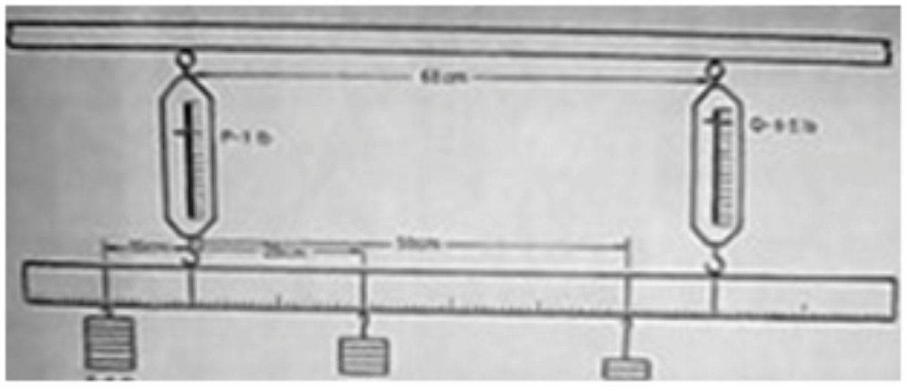

Figure 4.0: Meter rule suspended from the spring balances hanged on the wooden beam

**Method/Procedure**:

(I) Suspend the beam from the two spring balances as shown in the diagram

(ii) Note the reading on the spring balances before loading with the beam suspended (Let the readings be W1 and T1 (N) respectively)

(iii) Place a specified weights on the beam as instructed, and take the reading of the spring

balance to be (W2 and T2) N

(iv) The reaction on the support due to the weight added would be (W2-W1) N and (T2-T1) N (v) Repeat the experiment for different weights as given by your instructor

Tabulate your readings on the table as shown below:

Table 4.1; Table of Values

**EXERCISES**

|  |  |  |  |  |  |
| --- | --- | --- | --- | --- | --- |
| REACTIONS (T2-T1)Y (Nm) |  |  |  |  |  |
| CHANGE IN WT (N)  (T2-T1) |  |  |  |  |  |
| WT (N) |  |  |  |  |  |
| WT (N) |  |  |  |  |  |
| DISTAN CE  Y (m) |  |  |  |  |  |
| REACTIONS (W2-W1)X (Nm) |  |  |  |  |  |
| CHANGE IN WT (N) (W2-W1) |  |  |  |  |  |
| WT W1 (N) |  |  |  |  |  |
| WT W2 (N) |  |  |  |  |  |
| DISTAN CE  X (m) |  |  |  |  |  |
| S/N | 1 | 2 | 3 | 4 | 5 |

(i) Determine the reaction at the beam supports

(ii) Calculate the downward forces and upwards forces, write down observation you notice.

(iii) What is the difference between your calculated values and observed values?

(iv) What do you understand by

Beam?

(v) What is the difference between beam and column?

**EXPERIMENT 5**

**TITLE: MODULUS OF ELASTICITY**

**Aim/Objective:** To determine the Young Modulus of Elasticity of a Steel.

**Apparatus:** Rigid body, long steel wire, Vernier scale/rule suspended near the wire base, micrometre screw gauge, hanger and weights

**Theory:** Stress = Load/ Cross-sectional Area

Strain = Extension/Original Length

Young Modulus E = Stress/Strain

**DIAGRAM:**

RIGID BODY

4

SPRING

5

6 VERNIER SCALE

7

WEIGHT

8

Figure 5.1: Spring Balance, Weight and Vernier Scale Assembly

**Procedure**:

(i) Measure the length and diameter of the spring in mm

(ii) Apply a specified load to the hanger as shown in the diagram

(iii) Adjust vernier to zero

(iv) Add a small load and note the vernier reading

(v) Calculate the extension

(vi) Repeat for various load as given by your instructor

Tabulate your readings on the table: Initial value of the spring length in mm = ……..

Table 5.1: Values of the reading taken

|  |  |  |  |  |  |
| --- | --- | --- | --- | --- | --- |
| S/N | Load (N) | Vernier Reading  (mm) | Initial Reading (mm) | Extension (mm) |  |
|  |  |  |  |  |  |
|  |  |  |  |  |  |
|  |  |  |  |  |  |
|  |  |  |  |  |  |
|  |  |  |  |  |  |

**Exercises**:

(a) Plot the graph of load (N) against extension (mm). (b) What is the shape of your graph?

(c) What is the corresponding extension value (mm) when a load of ……….(N) is selected on your graph?

(d) Determine Modulus of Rigidity G and Young Modulus of Elasticity E.

(e) Compare the value of Young Modulus of Elasticity E calculated with the standard one in the textbooks.

(f) What is Young Modulus of Elasticity?

**EXPERIMENT 6**

**TITLE: TORSION**

**Objectives:** To observe the relationship between torque and angular deflection of a specimen subject to torsional loading and to determine the modulus of rigidity of the shaft material.

**Apparatus**: torsion apparatus, specimen, micrometer screw gauge or vernier caliper, meter rule, hanger and masses.

**Method:**

1. The specimen is set by introducing it through the hole on the fixed end of the apparatus and pushing it further into the other at the moving end and screwed tight using the provided grub screw.

2. The deflection gauge is at position which is about three – quarter of the length of the specimen measured from the fixed end.

3. The effective length of the specimen is measured.

4. A suitable load is applied e.g. 1kg to the hanger and the deflection on the deflection gauge is noted.

5. The load is increased by 1kg up to the minimum available size (depending on the strength of the shaft) each time recording the corresponding total value of θ.

6. The result gotten is tabulated as follows: Effective length of shaft L,

Diameter of shaft D,

Radius of torsion pulley 'a'.

Table 6.1: Values of results

**18**

|  |  |  |  |
| --- | --- | --- | --- |
|  | Deflection gauge | Dial gauge |  |
| S/N | Load mass (m/kg) | T o r q u e  T/Mga/N | Angular Deflection  е (Degree) | A n g u l a r D e f l e c t i o n in Radian | A n g u l a r  Deflection  е in degree | A n g u l a r Deflection in Radian | M e a n  (Radian) |
| 1  2  3  4  5  6  7  8 |  |  |  |  |  |  |  |

**REPORT TASKS QUESTION**

1. Derive the appropriate equation of torsion of circular shaft for data analysis.

2. Plot graphs for torque T vertically against deflection O and obtain the slopes.

3. Calculate the modulus of rigidity of the specimen.

4. Comment on the accuracy of measurements and calculations.

5. Comment on the values of modulus of rigidity of the specimen.

6. Suggest precautions you will take if you were to perform the experiment.

**PRACTICAL REPORT NOTES**

**PRACTICAL REPORT NOTES**

**PRACTICAL REPORT NOTES**

**Title: .........................................**

**Scale:**

x: ......................................

y: ......................................



**Title: .........................................**

**Scale:**

x: ......................................

y: ......................................



**PRACTICAL REPORT NOTES**

**PRACTICAL REPORT NOTES**

**PRACTICAL REPORT NOTES**

**Title: .........................................**

**Scale:**

x: ......................................

y: ......................................



**PRACTICAL REPORT NOTES**

**PRACTICAL REPORT NOTES**

**PRACTICAL REPORT NOTES**

**PRACTICAL REPORT NOTES**

**Title: .........................................**

**Scale:**

x: ......................................

y: ......................................



**PRACTICAL REPORT NOTES**

**PRACTICAL REPORT NOTES**

**PRACTICAL REPORT NOTES**